EXPERIMENT NO. 01
SIMULATION AND STUDY OF CHARACTERISTICS OF NMOS AND PMOS TRANSISTORS
―――――――――――――――――――――――――――――――――――――――――――――――――――――――
AIM
To simulate and study the transfer and drain characteristics of NMOS and PMOS transistors using LT Spice.
SOFTWARE USED
LT Spice, Electric VLSI
CIRCUIT DIAGRAM
The schematic simulation setups for NMOS and PMOS transistors are shown below:
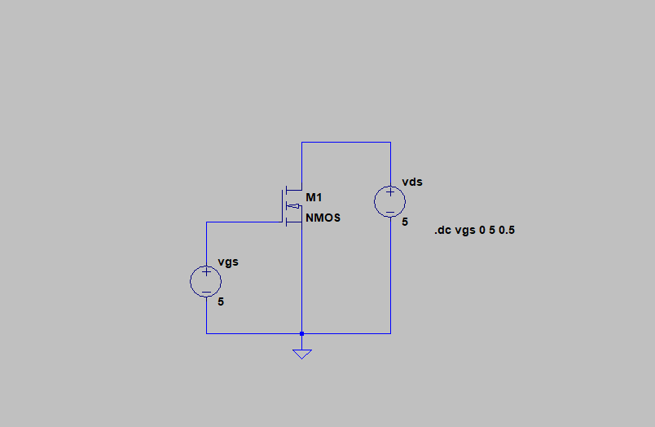
Figure 1.1: LT Spice Simulation Schematic of NMOS Transistor
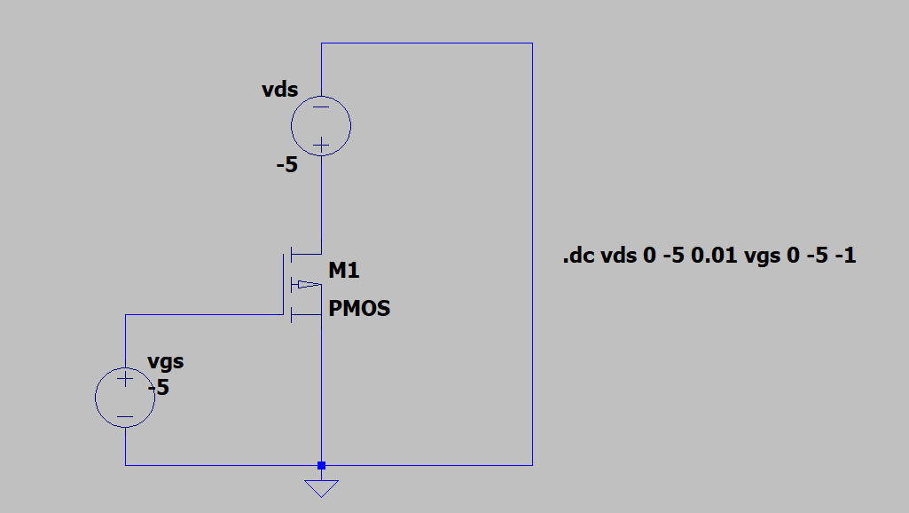
Figure 1.2: LT Spice Simulation Schematic of PMOS Transistor
Circuit symbols for n-channel and p-channel enhancement MOSFETs:
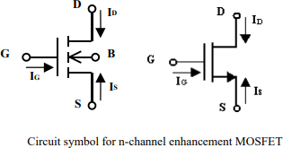
Figure 1.3: Circuit Symbol for N-Channel Enhancement MOSFET
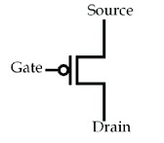
Figure 1.4: Circuit Symbol for P-Channel Enhancement MOSFET
SMALL THEORY
The MOSFET (Metal-Oxide-Semiconductor Field-Effect Transistor) is a four-terminal semiconductor device with Drain (D), Source (S), Gate (G), and Body/Substrate (B) terminals. Because the gate is electrically isolated by a thin layer of silicon dioxide, the gate draws virtually zero DC current (IG = 0).
1. NMOS Transistor Characteristics:
- Threshold Condition: Controlled by gate-to-source voltage VGS. Conduction occurs when VGS exceeds the threshold voltage VT (VGS > VT).
- Linear (Triode) Region: When VDS < (VGS - VT), drain-to-source current IDS increases linearly with VDS, behaving as a voltage-controlled resistor.
- Saturation Region: When VDS >= (VGS - VT), channel pinch-off occurs near the drain, and IDS saturates at a constant value determined primarily by VGS.
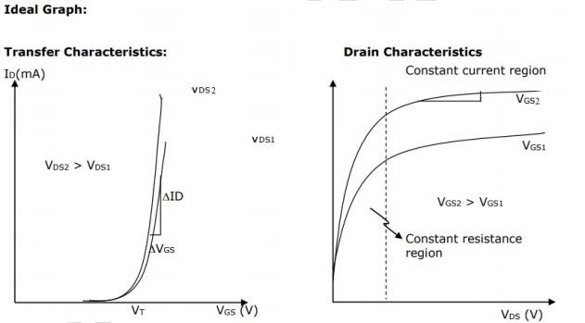
Figure 1.5: Ideal Transfer and Drain Characteristics of NMOS
2. PMOS Transistor Characteristics:
- Carrier Type: Utilizes a p-type channel in an n-substrate with positively charged holes as majority charge carriers.
- Operating Voltage: Operates with complementary polarity: conduction occurs when gate voltage is driven negative relative to source (VGS < VTP).
- Regions of Operation: Similarly exhibits linear and saturation regions based on the source-to-drain voltage and gate overdrive voltage.
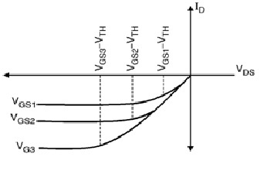
Figure 1.6: Ideal I-V Characteristics of PMOS
OUTPUT GRAPH
Simulated transfer and drain characteristics observed in LT Spice:
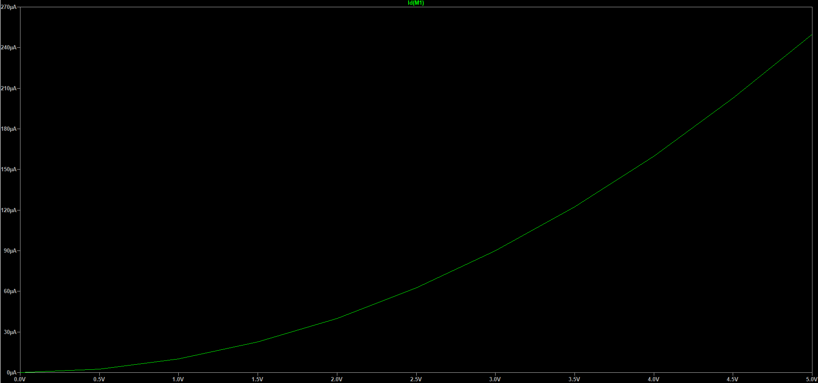
Figure 1.7: NMOS Transfer Characteristics (Id vs Vgs)
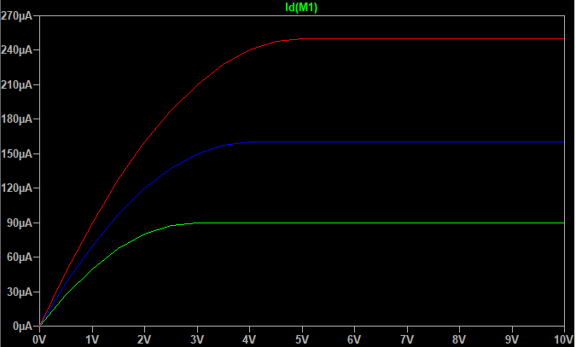
Figure 1.8: NMOS Drain Characteristics (Id vs Vds for varying Vgs)
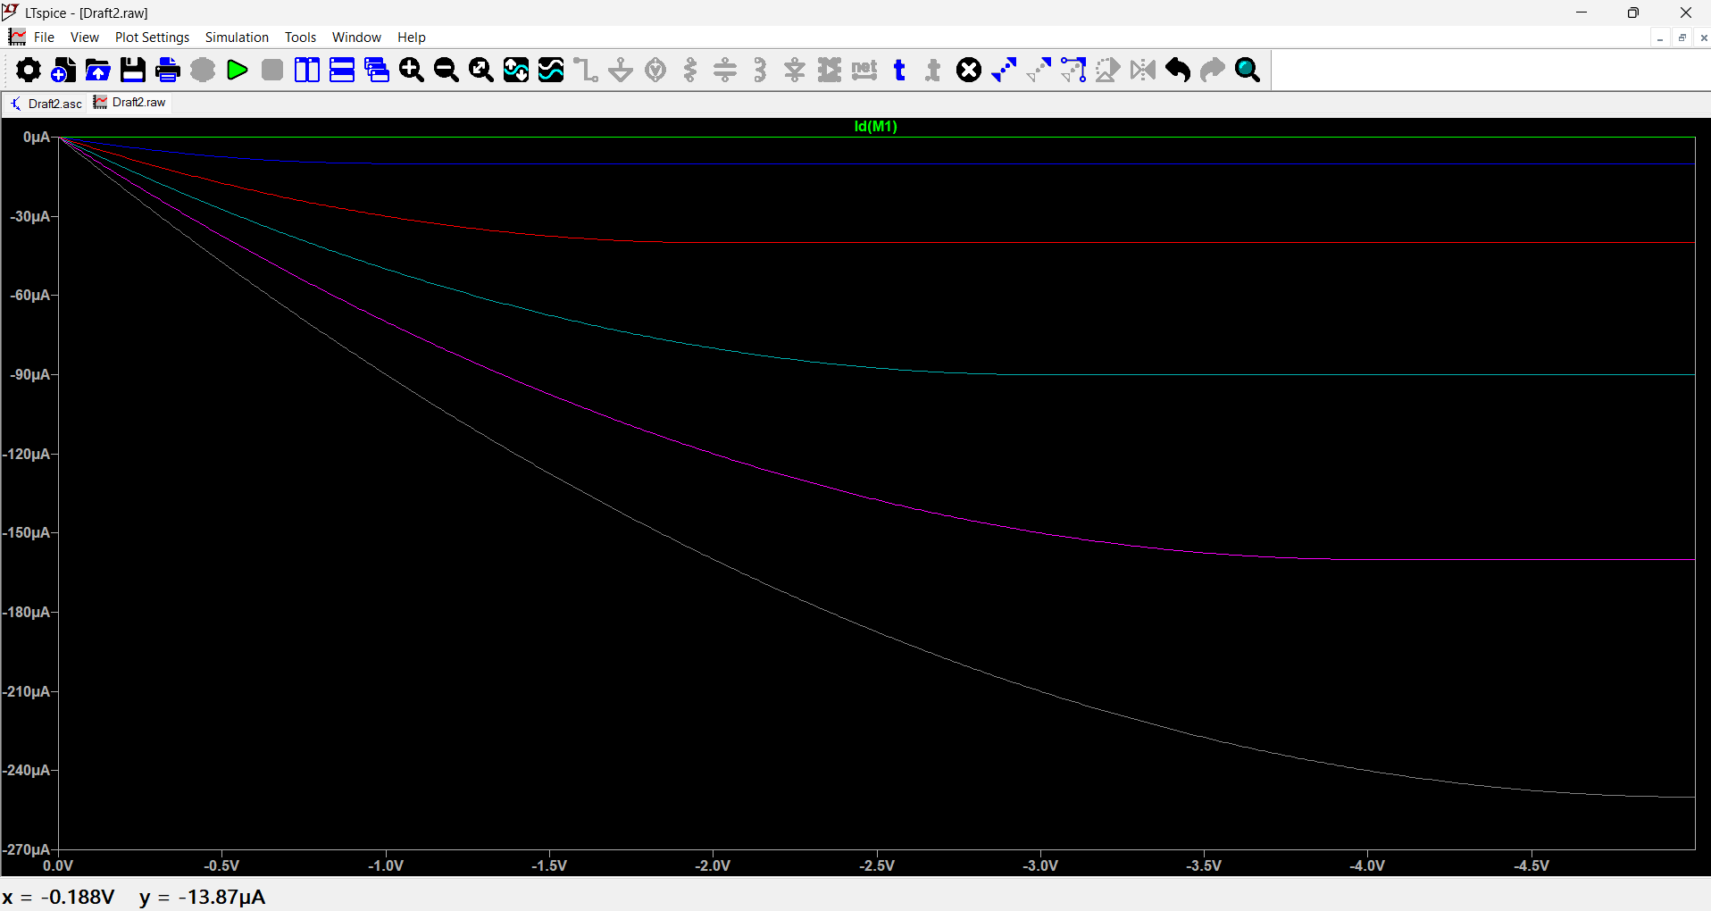
Figure 1.9: PMOS Drain Characteristics (Id vs Vds)
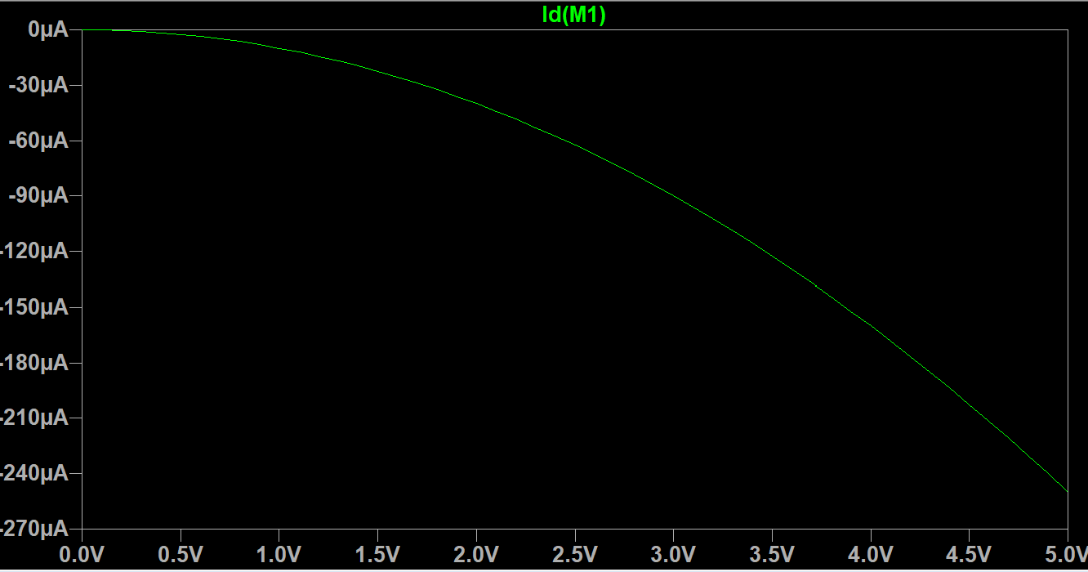
Figure 1.10: PMOS Transfer Characteristics (Id vs Vgs)

